GitHub was used to demonstrate controlled document changes within the ECG project. A separate branch was created to update the D&D traceability matrix without modifying the original document on the main branch. The changes were committed, submitted through a pull request and successfully merged into the main branch. Figures 1–5 document this process.
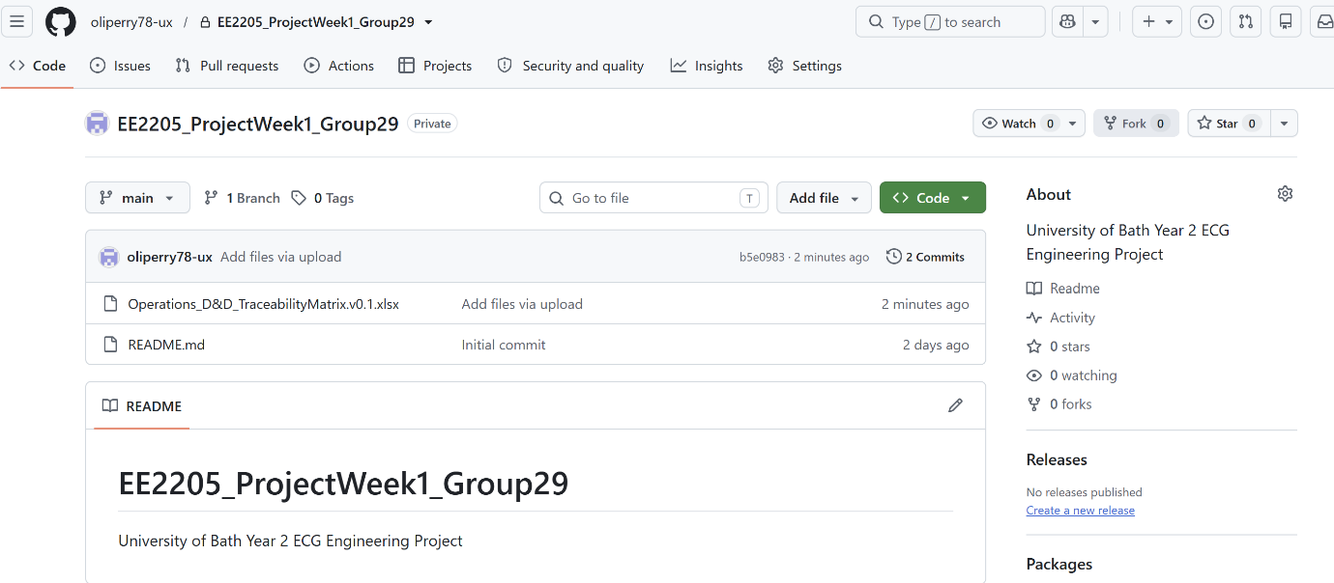
The original ECG Design and Development (D&D) traceability matrix was uploaded and committed to the main branch, establishing the baseline document before changes were made.
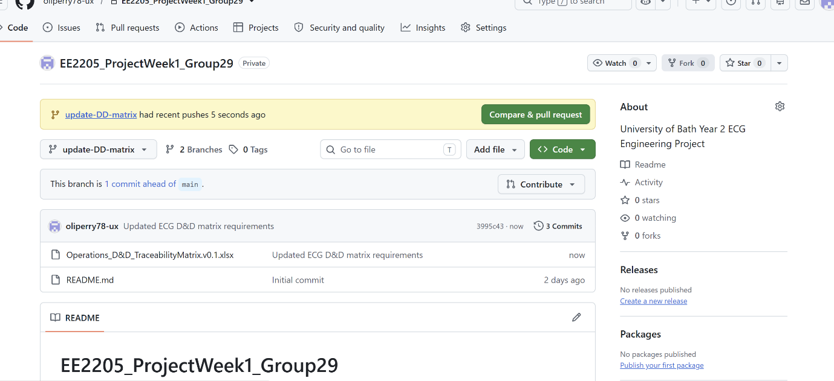
A revised D&D matrix, including the addition of Group 29 contributors' usernames, was committed to the update-DD-matrix branch. GitHub confirms that this branch is one commit ahead of main.
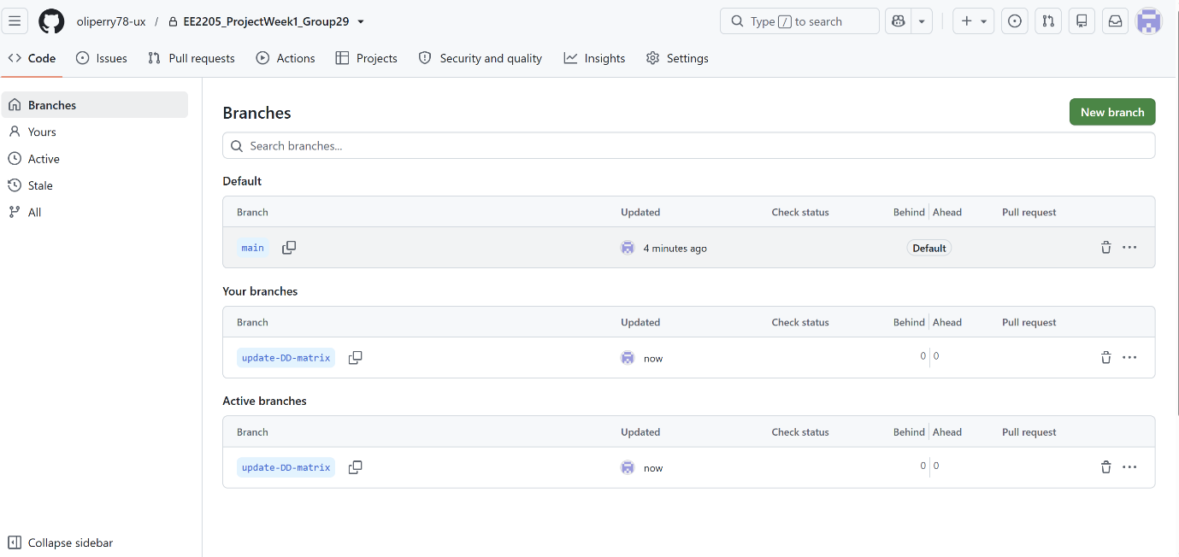
The GitHub branches page shows the original main branch and the separate update-DD-matrix branch, demonstrating that changes were developed independently of the main project version.
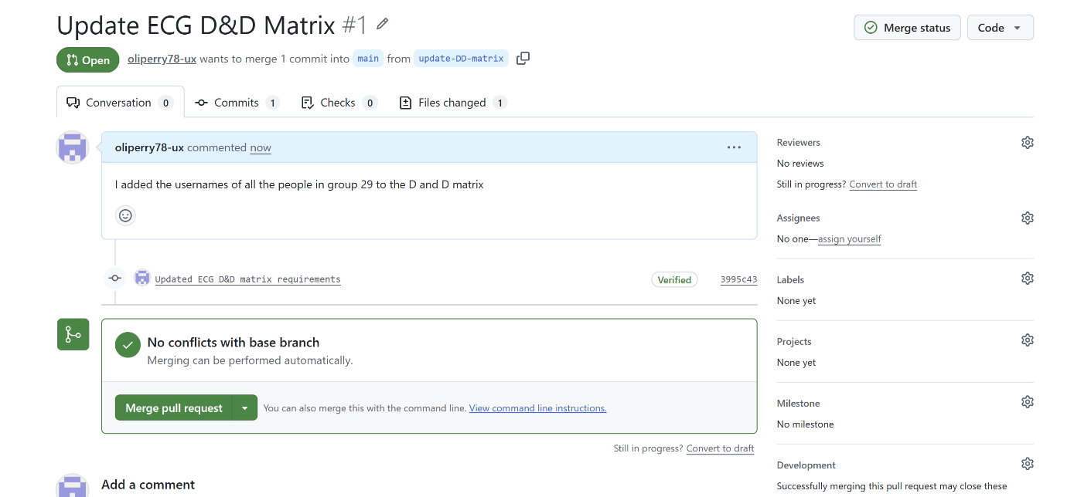
Pull request #1 was created to merge the updated D&D matrix from update-DD-matrix into main. GitHub confirmed that no merge conflicts were present.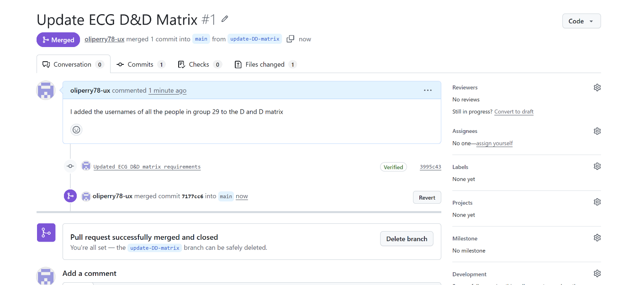
Pull request #1 was successfully merged, incorporating the updated D&D matrix into the main branch. GitHub records the completed merge, providing traceability of the document change.

